# Page Layout Challenge (updated 2022)

This assignment is meant to be a challenge. You will not receive direct assistance from your professor or TA, and may not use the IT learning center for this challenge. There are several ways to accomplish this challenge; there isn’t a set solution code.

You are provided with an HTML starter file, which you will need to make some edits too in order to accomplish the challenge. You will also need to configure all the CSS. Your start file looks like this:

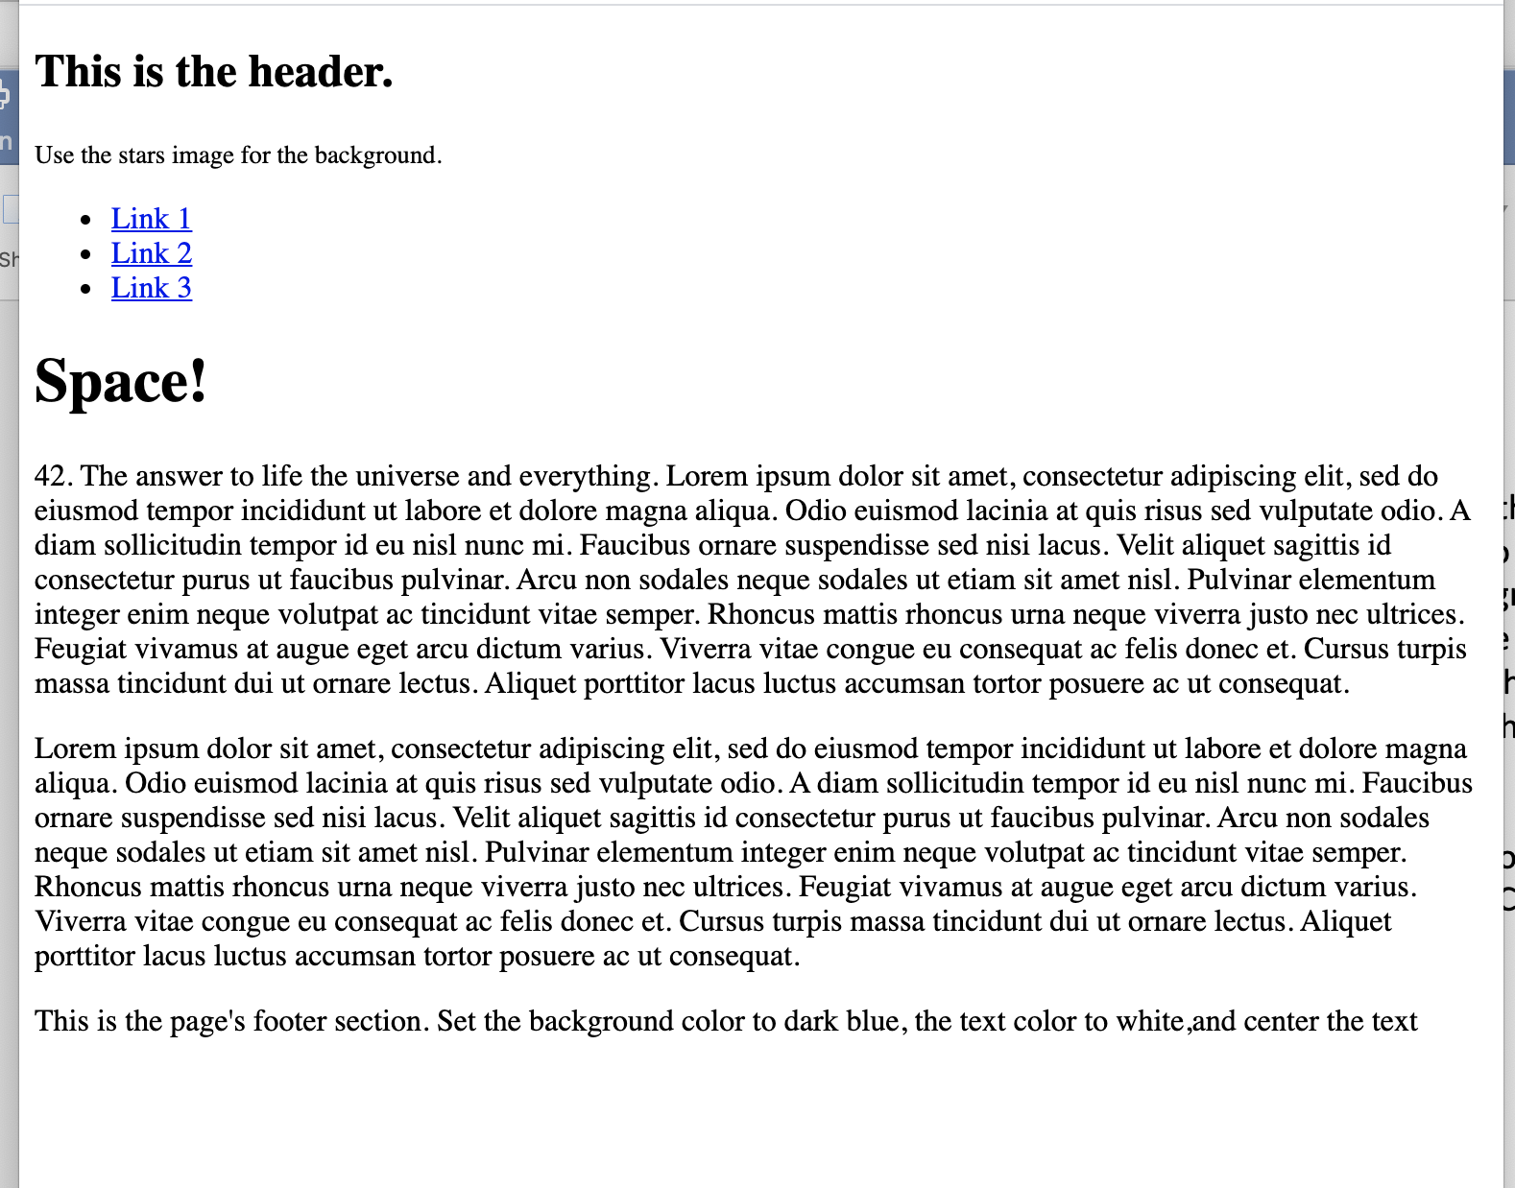

Some suggest resources that may help you:

* [HTML Semantic Elements](https://www.w3schools.com/html/html5_semantic_elements.asp)
* [Sample of a 2 Colum page design](https://www.w3schools.com/html/tryit.asp?filename=tryhtml_layout_float)
* [How to create equal height columns](https://www.w3schools.com/howto/howto_css_equal_height.asp)

Your finished page should look like this:

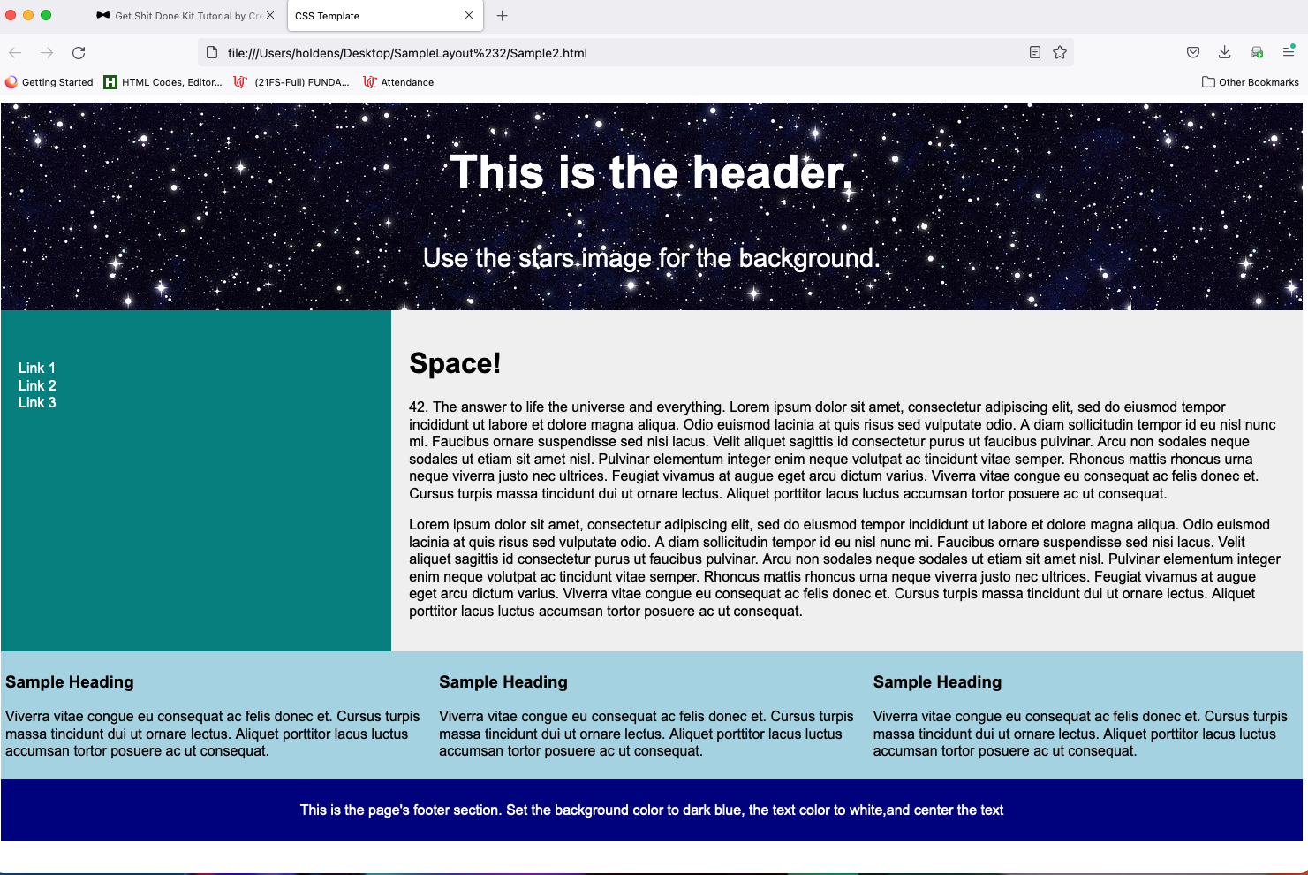

A hover effect should be applied to the nav links:



This page should NOT use responsive design. The nav section will remain to the left of the text, regardless of browser viewport size, and be a fixed percentages of the total page width, reguardless of the browser width (about 1/3 of total width).

The height of the containers containing the Lorum Ipsum text should adjust to fit the content in them. No text should overflow it's container at any browser width.

Exact color matches are not required, anything close to the colors pictured will suffice.

